**Challenge : Convert minutes into year and days**

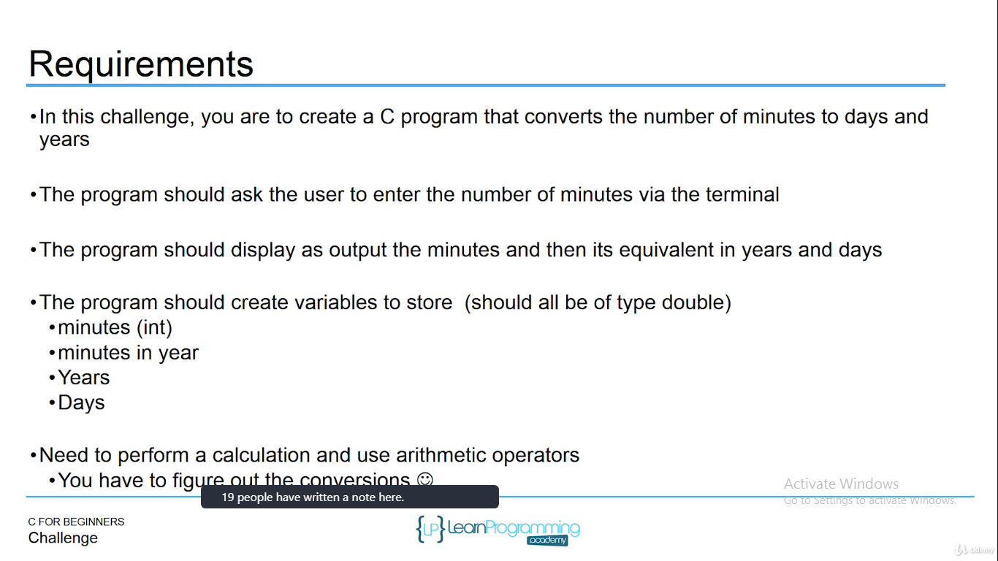

#include <stdio.h>

#include <stdlib.h>

int main()

{

int minutesEntered = 0;

double years = 0.0;

double days = 0.0;

double minutesInYear = 0;

printf("Please enter the number of minutes: ");

// get input from user

scanf("%d", &minutesEntered);

minutesInYear = (60 * 24 * 365);

years = (minutesEntered / minutesInYear);

days = (minutesEntered / 60.0) / 24.0;

printf("%d minutes is approximately %f years and %f days\n", minutesEntered, years, days);

return 0;

}

Output